Supply Chain Optimization
Project Description – Supply Chain Optimization :
This project focuses on designing and implementing a relational database system for supply chain optimization using MySQL. The system models key entities involved in the supply chain, including suppliers, manufacturers, distributors, products, inventory, orders, and logistics. Each table is structured with appropriate primary keys, foreign keys, and constraints to maintain data integrity and establish relationships between different components of the supply chain. The database enables efficient storage and retrieval of data related to product flow, stock levels, and order processing.
Furthermore, SQL queries are implemented to perform essential operations such as identifying low inventory levels for timely replenishment, analyzing total orders handled by distributors, evaluating transportation costs, and tracking order fulfillment status. These queries help in minimizing stock shortages, reducing logistics expenses, and improving overall operational efficiency. The project demonstrates how a well-structured database system can support decision-making and optimize supply chain management in real-world scenarios.

CREATE DATABASE :
CREATE DATABASE supply_chain_db;
USE supply_chain_db;
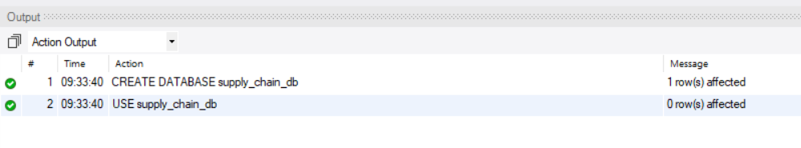

CREATE TABLE :
- Suppliers Table :
CREATE TABLE suppliers (
supplier_id INT PRIMARY KEY AUTO_INCREMENT,
name VARCHAR(100) NOT NULL,
contact VARCHAR(15),
city VARCHAR(50)
);

- Manufacturers Table :
CREATE TABLE manufacturers (
manufacturer_id INT PRIMARY KEY AUTO_INCREMENT,
name VARCHAR(100) NOT NULL,
location VARCHAR(50)
);
- Distributors Table :
CREATE TABLE distributors (
distributor_id INT PRIMARY KEY AUTO_INCREMENT,
name VARCHAR(100) NOT NULL,
region VARCHAR(50)
);
- Products Table :
CREATE TABLE products (
product_id INT PRIMARY KEY AUTO_INCREMENT,
name VARCHAR(100) NOT NULL,
manufacturer_id INT,
FOREIGN KEY (manufacturer_id) REFERENCES manufacturers(manufacturer_id)
);
- Inventory Table :
CREATE TABLE inventory (
inventory_id INT PRIMARY KEY AUTO_INCREMENT,
product_id INT,
quantity INT CHECK (quantity >= 0),
location VARCHAR(50),
FOREIGN KEY (product_id) REFERENCES products(product_id)
);

- Orders Table :
CREATE TABLE orders (
order_id INT PRIMARY KEY AUTO_INCREMENT,
product_id INT,
distributor_id INT,
quantity INT,
order_date DATE,
FOREIGN KEY (product_id) REFERENCES products(product_id),
FOREIGN KEY (distributor_id) REFERENCES distributors(distributor_id)
);
- Logistics Table :
CREATE TABLE logistics (
logistics_id INT PRIMARY KEY AUTO_INCREMENT,
order_id INT,
transport_mode VARCHAR(50),
cost DECIMAL(10,2),
delivery_status VARCHAR(50),
FOREIGN KEY (order_id) REFERENCES orders(order_id)
);

Insertion of Sample Data :
INSERT INTO suppliers (name, contact, city)
VALUES ('ABC Supplies', '9876543210', 'Delhi');

INSERT INTO manufacturers (name, location)
VALUES ('XYZ Manufacturing', 'Gurgaon');

INSERT INTO distributors (name, region)
VALUES ('Fast Distributors', 'North India');

INSERT INTO products (name, manufacturer_id)
VALUES ('Product A', 1);

INSERT INTO inventory (product_id, quantity, location)
VALUES (1, 100, 'Warehouse 1');

INSERT INTO orders (product_id, distributor_id, quantity, order_date)
VALUES (1, 1, 20, '2026-04-01');

INSERT INTO logistics (order_id, transport_mode, cost, delivery_status)
VALUES (1, 'Truck', 5000, 'In Transit');
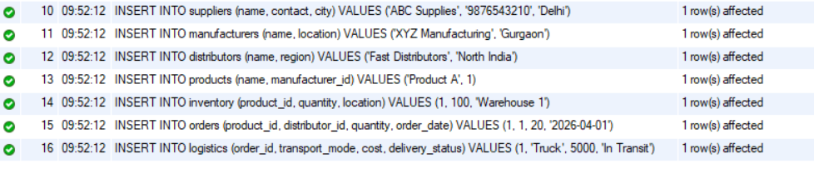

Check Low Stock :
SELECT p.name, i.quantity
FROM inventory i
JOIN products p ON i.product_id = p.product_id
WHERE i.quantity < 50;
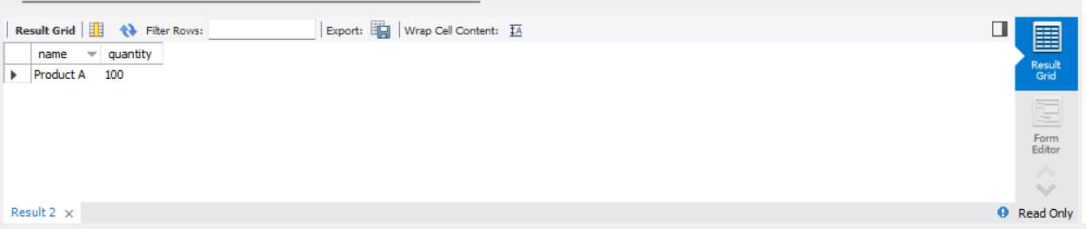
Total Orders by Distributors :
SELECT d.name, SUM(o.quantity) AS total_orders
FROM orders o
JOIN distributors d ON o.distributor_id = d.distributor_id
GROUP BY d.name;
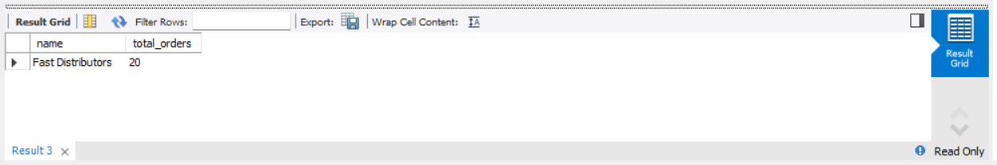
Transportation Cost Analysis :
SELECT transport_mode, SUM(cost) AS total_cost
FROM logistics
GROUP BY transport_mode;
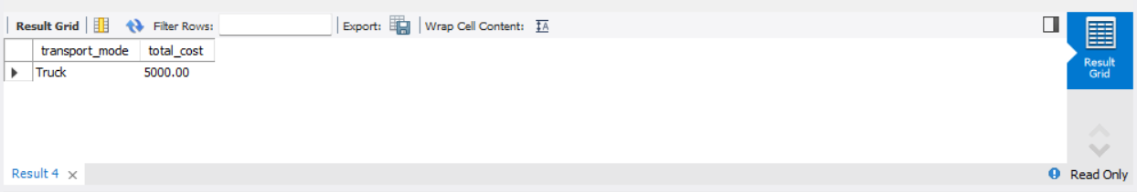

Order Fulfillment Status :
SELECT o.order_id, p.name, l.delivery_status
FROM orders o
JOIN products p ON o.product_id = p.product_id
JOIN logistics l ON o.order_id = l.order_id;
